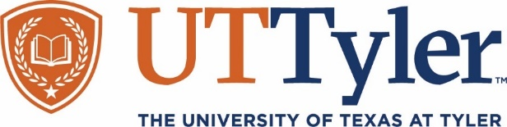

**Hospitalist *Grand Rounds***

***Sponsored and Coordinated by The Department of Medicine and The Office of Continuing Medical Education***

**Two Opportunities**

**Thursday, April 3, 2025 or April 10, 2025**

***12 -1 pm (Lunch will be served)***

***Location: Weiker Room, 1000 S. Beckham Ave., Tyler***

Steroids for the Internist: Hospital Use, Pearls and Pitfalls

**Speaker:**

**John Givler, DO**

*Assistant Professor of Medicine*

*Core Faculty, Internal Medicine*

*Director of Hospital Medicine Education*

*The University of Texas at Tyler Health Science Center*

*UT Tyler School of Medicine*

*Tyler, Texas*

**Objectives:**

At the end of this presentation, participants should have increased information to review common indications for steroid use in the hospitalized patient, recognize common pitfalls and adverse effects related to steroid use, discuss appropriate dosing, tapering, and administration of steroids and discuss instances where steroids have been studied recently in the literature.

***Hospitalist Grand Rounds are designed for Hospitalist, Family Medicine, Pulmonary, Critical Care, Nephrology, Endocrinology, Internal Medicine physicians, residents and medical students.***

The University of Texas at Tyler Health Science Center is accredited by the Texas Medical Association

to provide continuing medical education for physicians.

The University of Texas at Tyler Health Science Center designates this live educational activity for a maximum of ***1.0 AMA PRA Category 1 creditTM***. Participants should only claim credit commensurate with the extent of their participation in the activity.

 **ABIM MOC Credit**

Successful completion of this CME activity, which includes participation in the evaluation component, enables the participant to earn up to one (1) MOC point in the American Board of Internal Medicine’s (ABIM) Maintenance of Certification (MOC) program. Participants will earn MOC points equivalent to the amount of CME credits claimed for the activity. It is the CME activity provider’s responsibility to submit participant completion information to ACCME for the purpose of granting ABIM MOC credit.